

**Python Project**

**Submitted To**:- *Mr. Amarnath Mitra Sir*  
 (FORE School of Management, New Delhi)

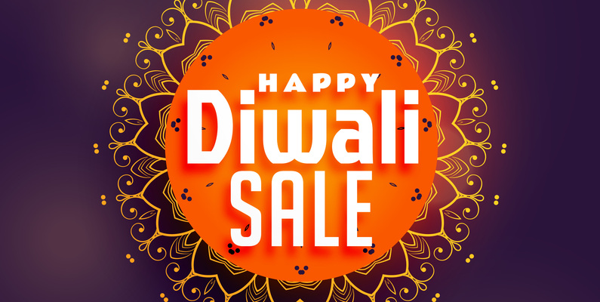

**Submitted By**:-

Name:- KAUSTUBH VARSHNEY

Roll No.- 045015  
 Section- H

BDA-04, Batch of 2023-2025

Contact Details:-

Email:-045015@fsm.ac.in

**Project Objectives:-**

I scraped and analyses the data of Diwali Sales which I extracted from the search engine. Diwali is a time when people traditionally exchange gifts, purchase new clothes, electronics, and home appliances. This leads to increased consumer spending. E-commerce platforms like Amazon, Flipkart, and Snapdeal have played a substantial role in the Diwali sales boom, offering significant discounts and deals during the Diwali season. In recent years, online sales during Diwali have shown remarkable growth, and more consumers are opting for online shopping due to convenience and competitive pricing.

I analysed the data on the basis of age, product ID, gender, age, occupation, zone, state, marital status, So that we can get to know that in which factor we will have to focus for upcoming Diwali that we can increase our sales.

**Libraries Used:-**

* Python
* BeautifulSoup
* Requests
* Numpy
* Pandas
* Matplotlib
* Seaborn

**Main Objectives:-**

* To show the comparison between males and females buyers during the Diwali
* To show the percentage of how many males and females of total buyers purchased the products
* To show the age group wise purchaser power.
* To show the percentage of age groups with the totals
* To show the comparison between the states wise purchasing power during the Diwali.
* To show the comparison between the purchasing power of married and non-married peoples.

**Analysis:-**

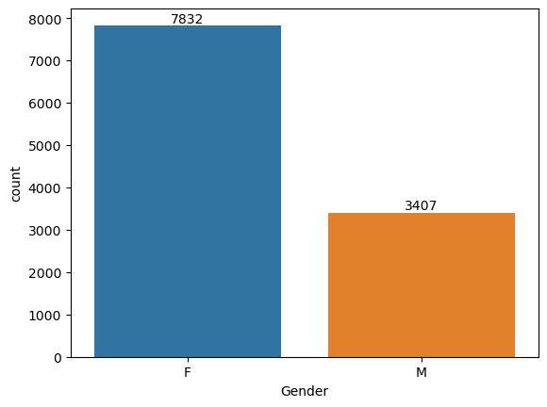

This above graph shows the comparison between Males and Females buyers. By this help now one can target the audience on upcoming Diwali.

2-

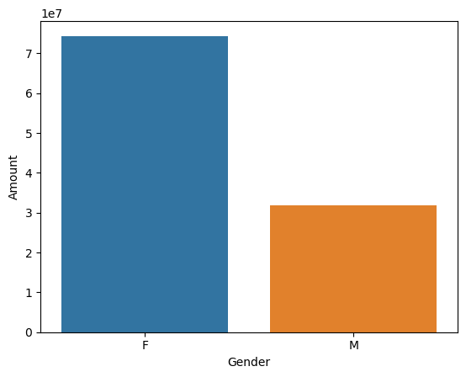

This shows the percentage of males and females.

3-

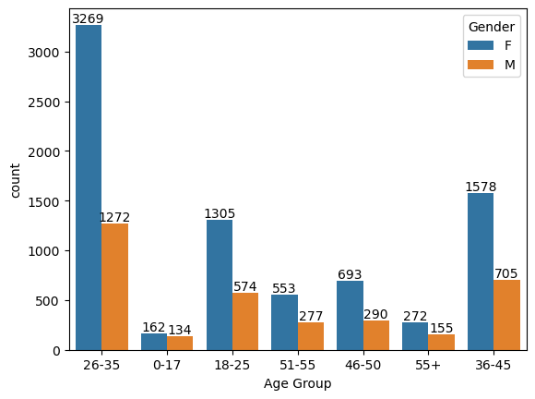

This shows the age group wise data manipulation.

4-

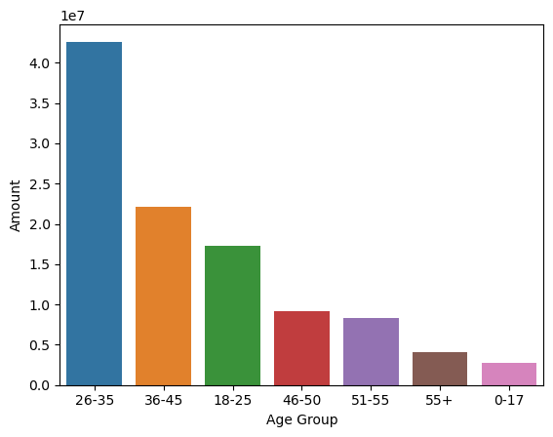

Percentage wise allotting as per the given data.

5-

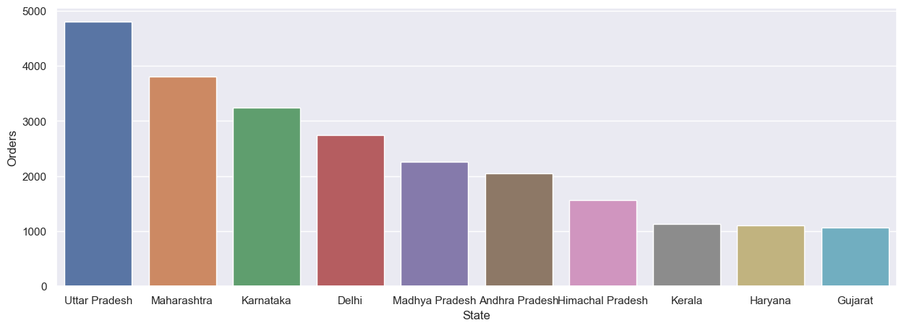

The above shows the data related to the states.

6-

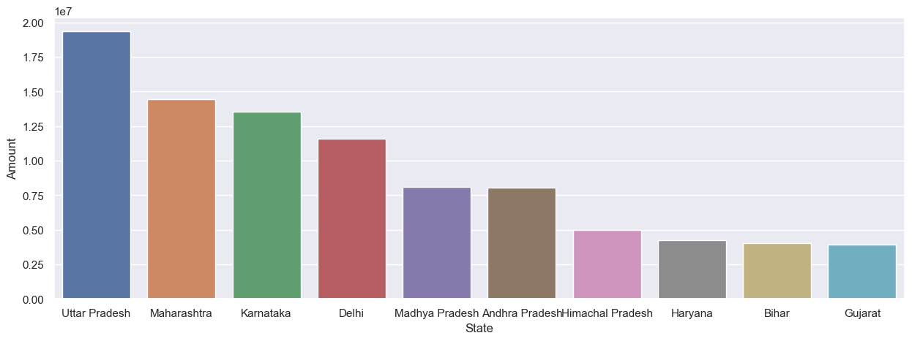

The above shows total amount/sales from top 10 states

7-

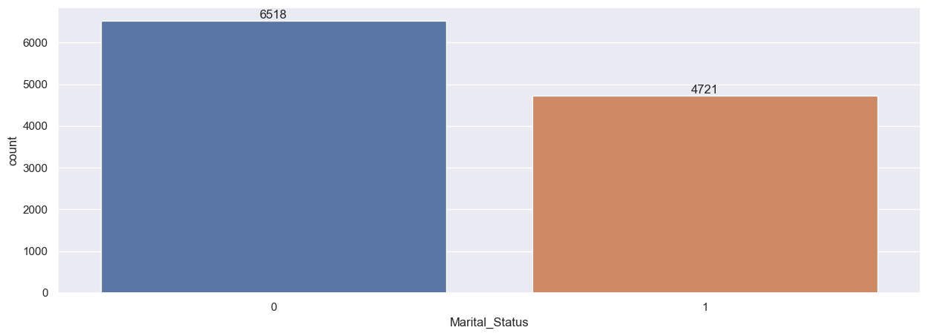

This shows the buyers marital status.

8-

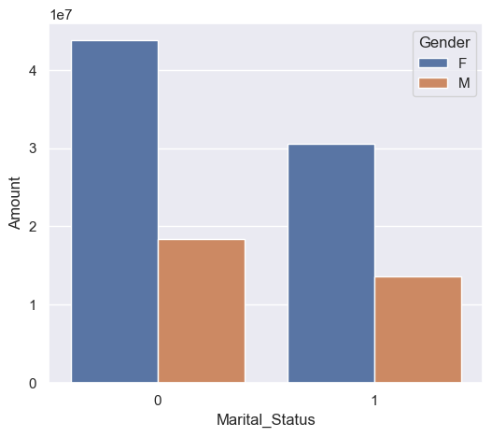

By the above information we can assume that Married individuals may be more likely to purchase gifts for their spouses, children, and extended family members during Diwali. This can lead to increased sales in categories such as clothing, jewelry, and electronics as people buy gifts for their loved ones. Online shopping behavior during Diwali can also be influenced by marital status. For example, married couples may jointly make online purchases for their households, impacting the types of products bought and the overall spending levels.

9-

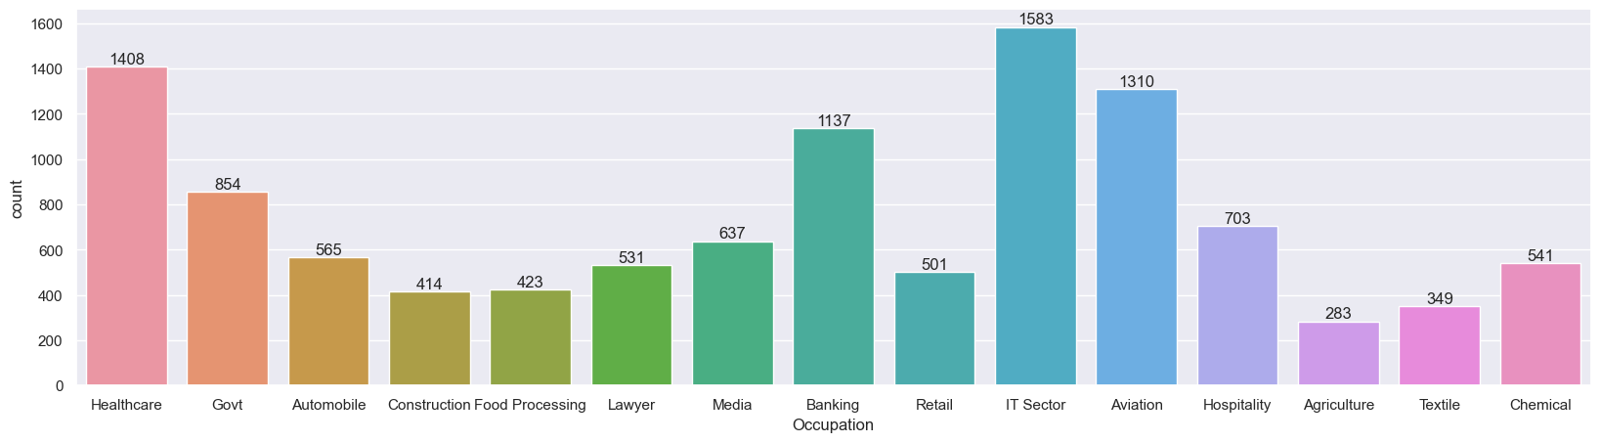

This shows which sector has maximum share in Diwali sales.

From this, we can assume that IT peoples have lot of buyer power instead than others as In many IT workplaces, there can be peer pressure to participate in Diwali celebrations and gift exchanges. This can lead to increased shopping as employees aim to match or surpass their colleagues' gifting efforts. Many IT professionals, especially those who work long hours, may use the Diwali season as an opportunity to invest in home decor and furnishings. This includes buying items like furniture, home appliances, and other products to spruce up their living spaces for the festivities.

10-

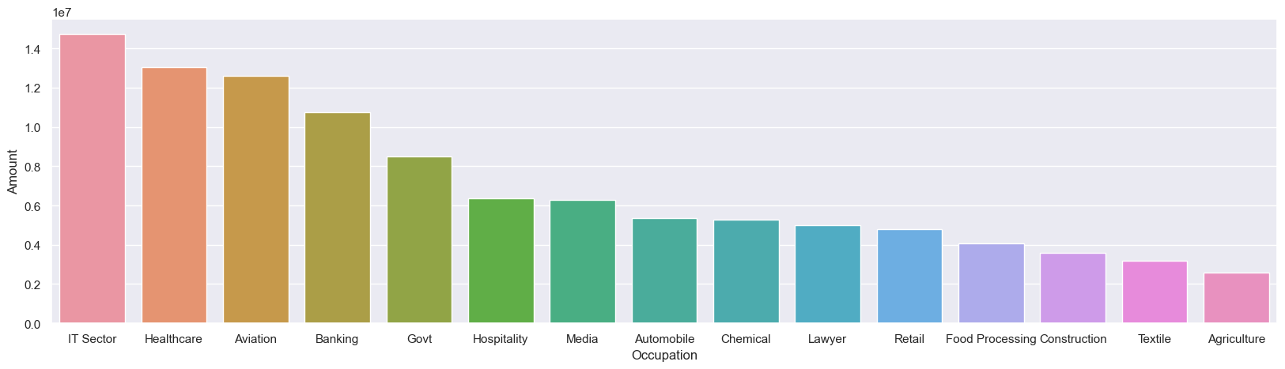

So from above again, IT professionals often receive competitive salaries and benefits, including bonuses and stock options. This results in a higher disposable income compared to many other sectors. With more money to spend, they are more likely to engage in shopping during festivals like Diwali. As mentioned earlier, many IT companies offer festive bonuses and incentives during Diwali. These bonuses can be substantial and encourage employees to spend on gifts, celebrations, and personal purchases.

It clears we should target IT Sector peoples in upcoming festivals. So that we can gain maximum profits and we can get big market share easily with low investment.

11-

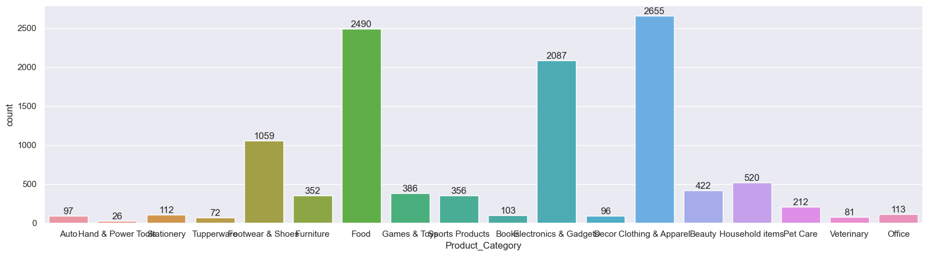

Diwali is a time when people traditionally wear new and special clothing to celebrate the festival. It's considered auspicious to wear fresh attire during this period. Many individuals and families take this opportunity to buy new and stylish clothes for themselves and their loved ones. For many families, shopping for new clothes during Diwali is a cherished tradition that has been passed down through generations. It's not just about buying garments but also about upholding cultural and family customs

12-

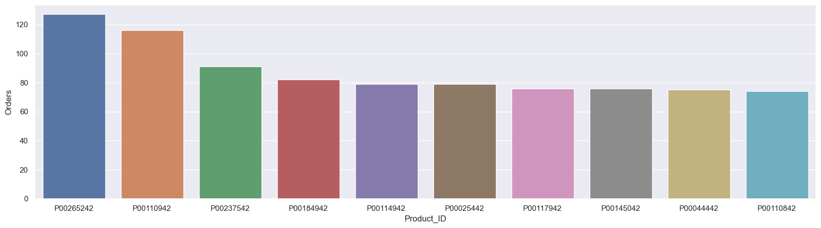

It describes only about the sales of a particular product with the specific ID.

